
SE-401L Human Computer Interaction Lab
Sir Dr. Hamid Ullah
16 April 2026
HCI Lab Task 1 Web Accessibility Evaluation
Ali Khan – 23MDSWE248
Visit Github
HCI Lab_07
University of Engineering and Technology Mardan

Website: SkyTech Developers (https://skytech-developers.vercel)

Checklist Used: Yale WCAG 2.1 Checklist (https://usability.yale.edu/web-accessibility/articles/wcag2-checklist)

Images of SkyTech Developers:

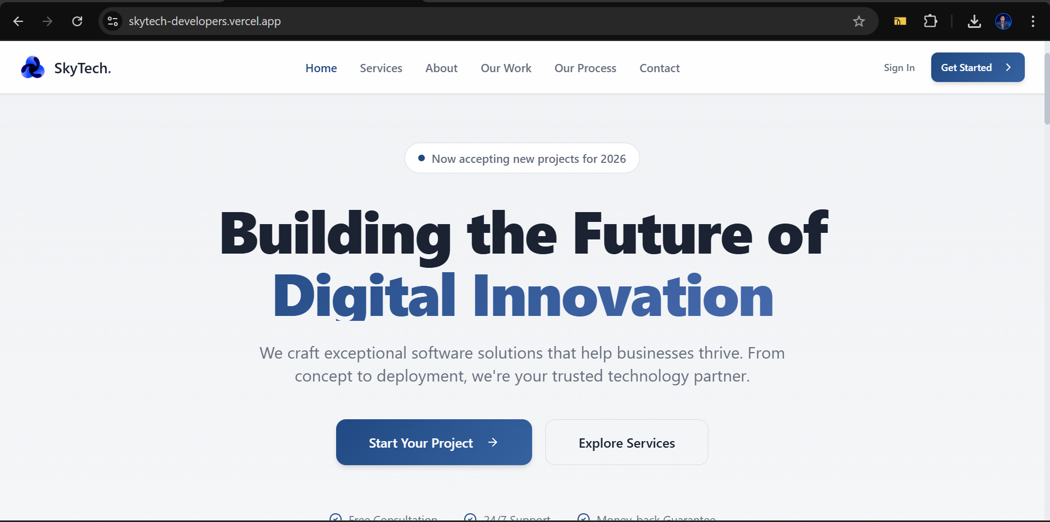
Figure 1

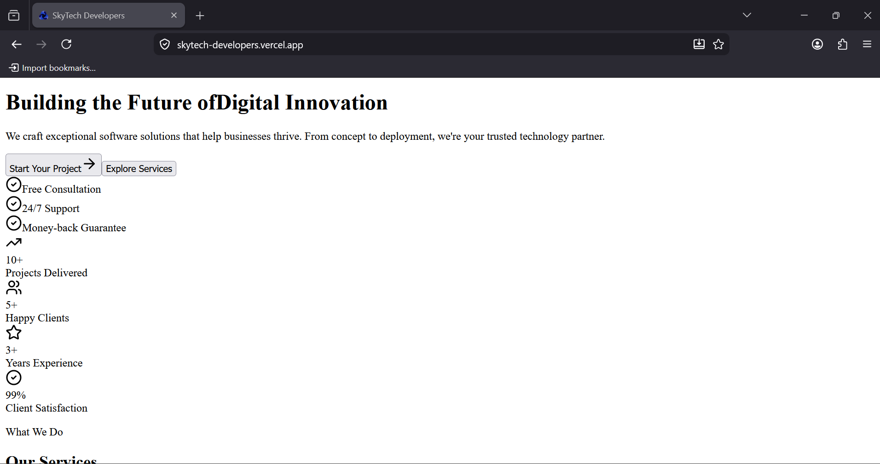
Figure 2

OVERVIEW
WCAG Criterion | Description | Level | Status
1.1.1 Non-text Content | Images alt text etc | A | PARTIAL
1.2.1 Audio/Video Only |  | A | N/A
1.3.1 Info and Relationships | Semantic tags and proper usage of anchor and button tags | A | PARTIAL
1.3.2 Meaningful Sequence | All website content is visible without styles in a structure way or not (Fig2) | A | PASS
1.3.4 Orientation | Responsive and visible on any orientation (portrait or landscape) | AA | PASS
1.4.1 Use of Color | Proper colors and contrast | A | PARTIAL
1.4.2 Audio Control |  | A | N/A
1.4.3 Contrast Minimum | images of that is at least 24px and normal weight or 19px and bold, use a contrast ratio that is at least 3:1. | AA | FAIL
1.4.4 Resize Text | Define responsive text units | AA | PARTIAL
1.4.5 Images of Text | Avoid images of text | AA | PASS
1.4.10 Reflow | The content should be visible at 320px without horizontal scrolling | AA | PASS
1.4.11 Non-text Contrast | Color contrast should be at least 3:1 so that different parts can be distinguished | AA | FAIL
1.4.12 Text Spacing | Avoid using pixel for text spacing like (line-height, height) | AA | PARTIAL
2.1.1 Keyboard Accessible | Keyboard shortcuts applicable or not | A | FAIL
2.1.2 No Keyboard Trap | Make sure the user can move focus to and from all focusable elements using a keyboard only. | A | PASS
2.2.2 Pause, Stop, Hide | If content does automatically move, blink, scroll, or update, provide a way to pause, stop, or hide | A | FAIL
2.4.1 Bypass Blocks | Provide a link to skip to the main content as the first focusable link on the page. | A | FAIL
2.4.2 Page Titled | Make sure each web page has a title tag that is descriptive, informative, and unique. | A | FAIL
2.4.3 Focus Order | Create a logical tab order through links, form controls, and interactive objects. | A | PARTIAL
2.4.4 Link Purpose | If the visible text alone is not sufficient to convey meaning, use advanced techniques to provide additional meaning, such as ARIA attributes, screen reader only text, or the title attribute. | A | FAIL
2.4.5 Multiple Ways | Each website should include at least two of the following: a list of related pages; table of contents; site map; search; or list of all pages. | AA | PARTIAL
2.4.6 Headings and Labels | Ensure that on each page, headings, landmark labels, and form labels are unique unless the structure provides adequate differentiation between them. | AA | PARTIAL
2.4.7 Focus Visible | Do not rely on browser default focus styles. | AA | FAIL
3.1.1 Language of Page | Provide a lang attribute on the page’s html element. | A | PASS
3.2.1 On Focus | When the focus change, the page should not cause a change in page content | A | PASS
3.2.2 On Input | When a user inputs information or interacts with a control, the page should not cause a change in page content, | A | PASS
3.2.3 Consistent Navigation | When components are repeated across web page, they should appear in the same relative order | AA | PASS
3.2.4 Consistent Identification | When components have the same functionality across several web pages, the components are labeled consistently on each page. | AA | PASS
3.3.1 Error Identification | Programmatically indicate required fields using the required | A | FAIL
3.3.2 Labels or Instructions | Use semantic, descriptive labels for inputs. | A | Pass
3.3.3 Error Suggestion | If an input error is detected and if suggestions for correction are known, provide suggestions for fixing the submission. | AA | Pass
4.1.2 Name, Role, Value | Avoid creating custom widgets when HTML elements already exist. For example, use a and button tags appropriately. | A | FAIL
4.1.3 Status Messages | When conveying a status message, use ARIA live regions or ARIA alerts to announce the message to screen reader users. | AA | FAIL

Task #02

App: InDrive (Android)

Checklist: Android Accessibility Checklist (MIT/Android Docs)

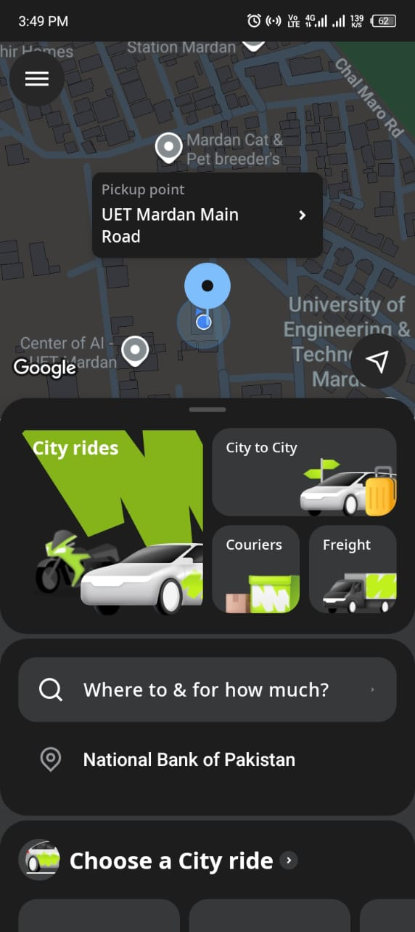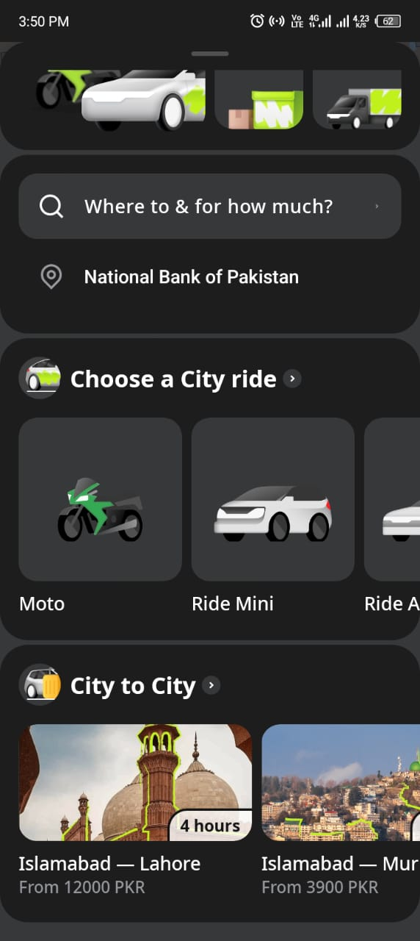

# | Accessibility Rule | What It Means | Status | Finding
1 | Labeling UI Controls | Every button, icon, and input must have a content description so screen readers can announce it | PARTIAL | Main action buttons (book ride, confirm) are labeled, but some icon-only buttons (close, back arrow, filter icons) lack content descriptions
2 | Labeling Images | Images conveying meaning must have descriptive text alternatives | PASS | Profile photos and map icons have basic labels; decorative images are not announced
3 | Providing Hints for Input Fields | Text input fields should tell the user what to enter, not just show a placeholder | PARTIAL | "Enter destination" field has a hint, but some promo code and coupon fields rely only on placeholder text that disappears on tap
4 | Grouping Related Content | Related UI elements should be grouped so screen readers treat them as one unit | FAIL | Fare details (price, distance, time) are read as separate unrelated items instead of one grouped card
5 | Making Custom Views Accessible | Custom-drawn views must manually implement accessibility events and descriptions | FAIL | The interactive map (driver location, route path) is a fully custom view with no accessibility semantics blind users get no information about the map
6 | Enabling Focus Navigation | All interactive elements must be reachable and usable via directional (D-pad/switch) navigation | FAIL | The map-based ride selection screen is not keyboard/switch navigable; users cannot select pickup point without touch
7 | Managing Focus Order | Focus should move in a logical, top-to-bottom, left-to-right order through the screen | PARTIAL | Most screens have a reasonable focus order, but the bottom sheet (fare negotiation panel) disrupts focus and jumps unexpectedly
8 | Announcing Dynamic Content Changes | When content on screen updates automatically, TalkBack must be notified via accessibility events | FAIL | Driver location updates, fare changes, and ride status changes (searching driver found) are not announced to TalkBack users
9 | Providing Accessible Alternatives to Gestures | Any feature requiring a swipe, drag, or multi-finger gesture must have an alternative | FAIL | Swiping to confirm ride and dragging the map pin to set location have no accessible button alternative
10 | Supporting Large Text / Font Scaling | UI must remain readable and functional when the user increases system font size | PARTIAL | Most text scales correctly but fare negotiation cards and driver info cards clip text or overflow their containers at 150%+ font size
11 | Ensuring Sufficient Touch Target Size | Interactive elements must be at least 48×48 dp so they are easy to tap | PARTIAL | Primary action buttons meet size requirements, but the map zoom buttons, promo code field icon, and notification dismiss buttons are visibly smaller than 48×48 dp
12 | Using Color with Sufficient Contrast | Text and UI elements must meet minimum contrast ratios so low-vision users can read them | FAIL | Light gray status text on white background (e.g., "Finding your driver…") and light text on the map overlay do not meet the 4.5:1 contrast requirement
13 | Not Relying on Color Alone | Information must not be conveyed by color only — always pair color with text or icon | PARTIAL | Driver availability and surge pricing are indicated with color-coded map zones but no text label or pattern to differentiate them
14 | Providing Captions / Audio Alternatives | Audio content or video tutorials should have captions or text equivalents | N/A | No video or audio-only content found in the version evaluated
15 | Testing with TalkBack | The app should be fully usable when Android's built-in screen reader (TalkBack) is active | FAIL | Core user flow entering destination, negotiating fare, confirming ride cannot be completed end-to-end using TalkBack alone due to unlabeled controls and inaccessible map

Overall Result: Poor Accessibility Compliance
Status | Count
PASS | 2
PARTIAL | 6
FAIL | 6
N/A | 1

Task #03:
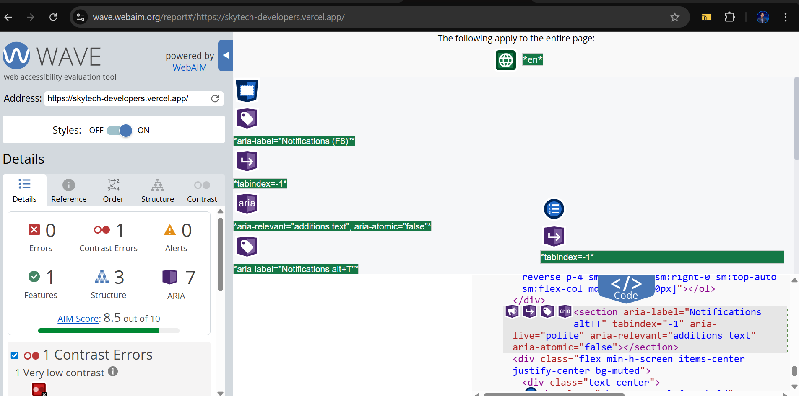
Figure 3

Summary:
According to my observation the automated tool did not find complete errors as we found in manual checking, it only found 1 error of contrast and directly scored the whole website as 8.5/10. The reference image.

Task#04:
I turned on the TalkBack feature on my phone and tried to use WhatsApp without looking at the screen.
At first, it was difficult to use because I am not used to controlling the phone with gestures and voice feedback. TalkBack reads everything on the screen, but sometimes it feels slow and overwhelming because it reads too much information.
One problem I faced was navigation. Moving between chats and options required specific gestures, and I often made mistakes. It was also hard to quickly find a specific chat because TalkBack kept reading each item one by one.
Typing messages was another challenge. Using the keyboard with TalkBack was slow, and I had to be very careful to select the correct letters. Sometimes I accidentally pressed the wrong keys, which made typing frustrating.
However, after some time, I got slightly better at using it. Basic tasks like opening a chat and listening to messages became easier, but overall it still took much more time compared to normal use.
In conclusion, using WhatsApp with TalkBack alone is possible, but it is not very easy for beginners. It requires practice, and even then, it feels slower and less efficient.

Task#05
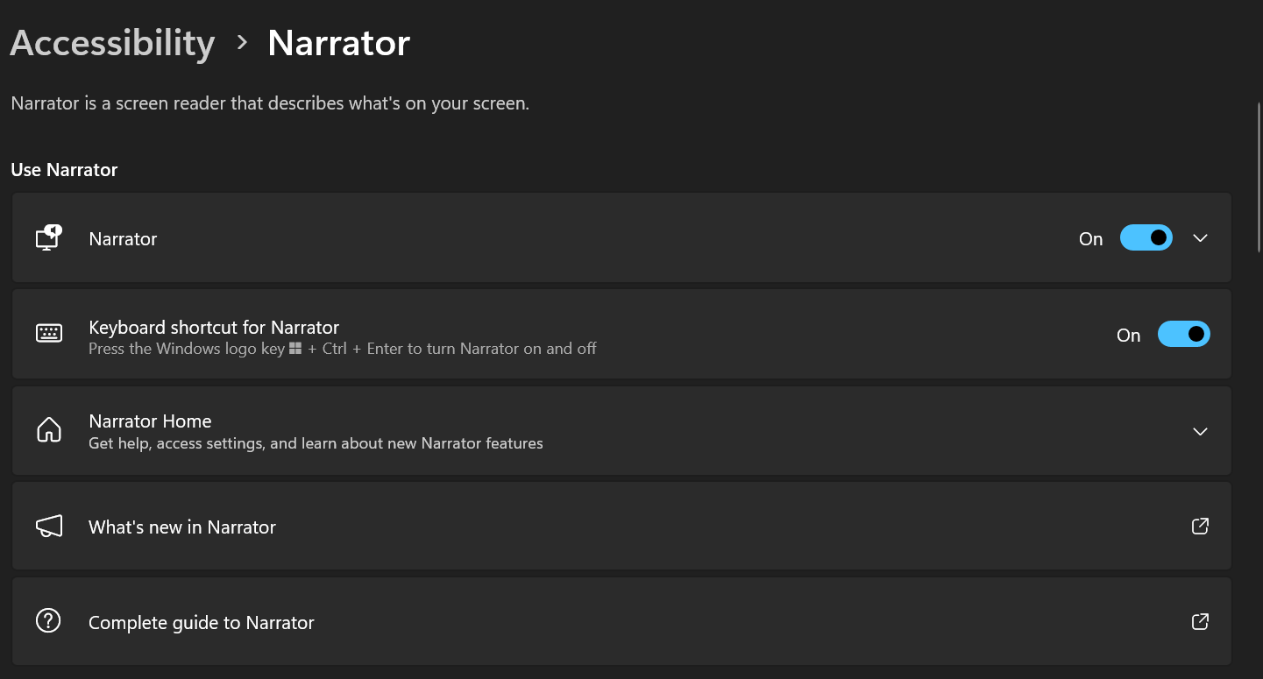
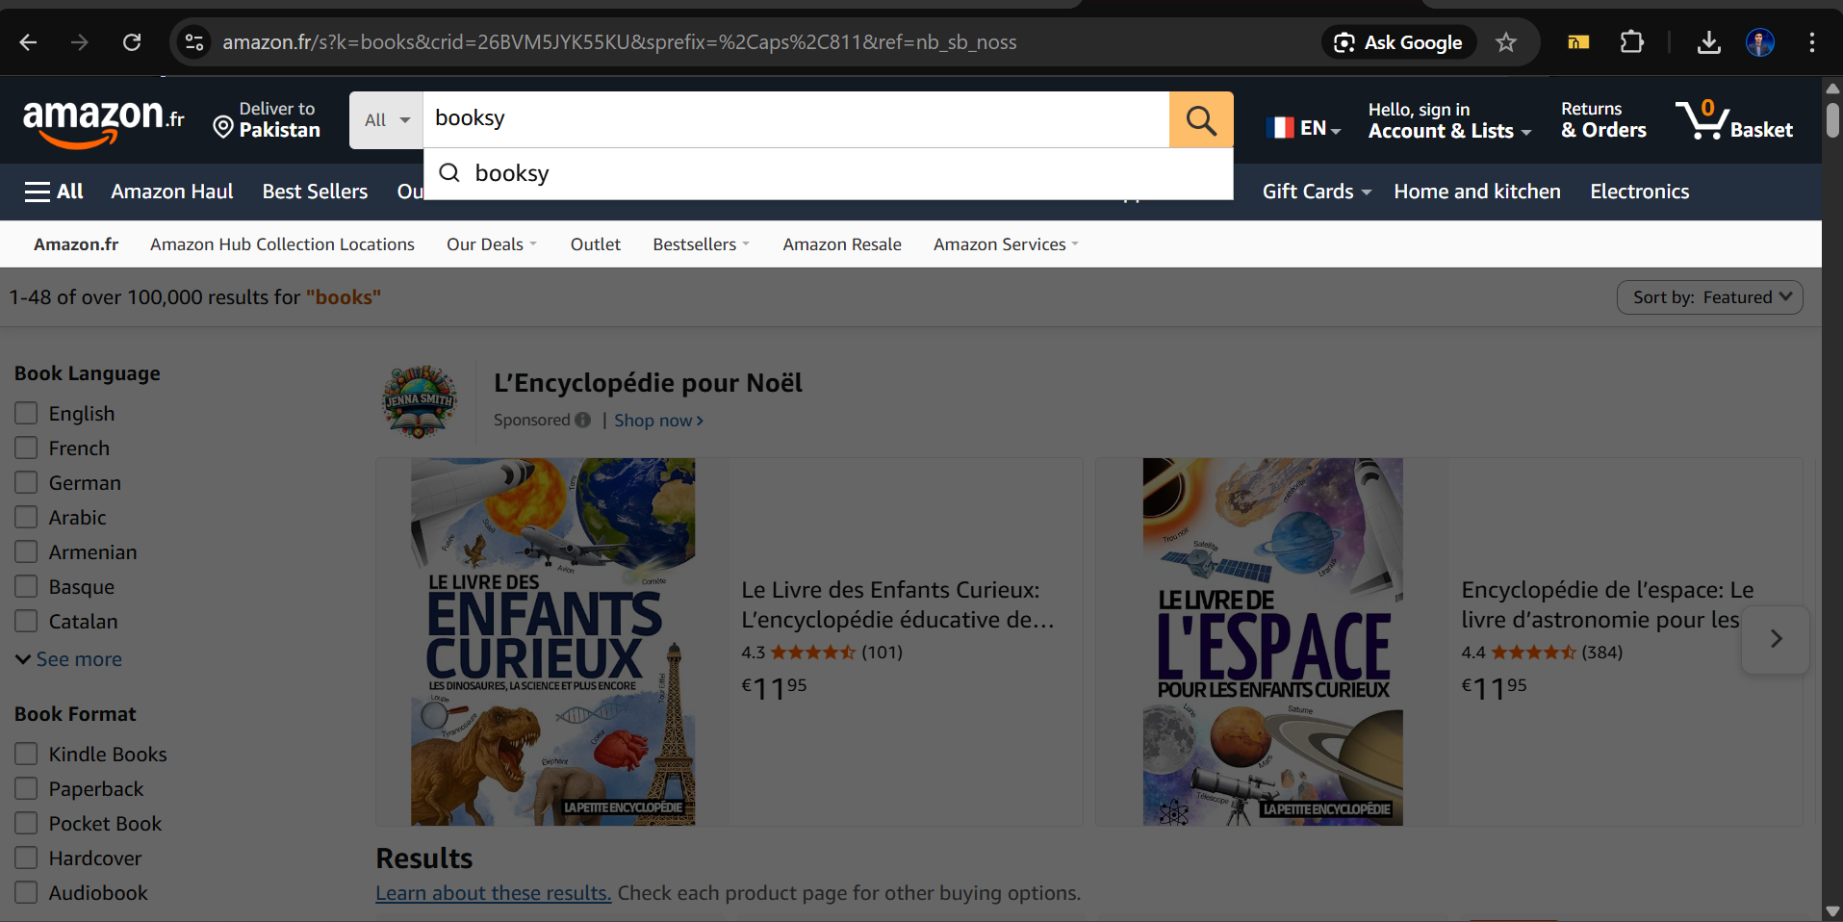

I used Windows Narrator and tried to browse the Amazon website without using a mouse. My goal was to find books on interactive design.
While doing this task, I faced several problems. First, when the website loaded, the narrator started reading from the header and navigation menu instead of going directly to the main content. It read a lot of unnecessary items like menu options, ads, and links before reaching the actual book section. This made the process slow and confusing.
Another issue was navigation. Moving between sections using the keyboard was not very smooth. Sometimes it was hard to understand where I was on the page, and I had to go through many unrelated elements before finding the search results.
Also, when I searched for “interactive design books,” the narrator did not directly focus on the results. Instead, it continued reading other parts of the page, which made it difficult to quickly find relevant books.
Overall, the experience was frustrating and time-consuming. The website is not very friendly for screen reader users because it does not prioritize important content. It requires a lot of extra effort to skip unnecessary information and reach the desired results.

